FACULTY EVALUATION
Programme Name: SBVP ALUMNI MASTERCLASS - GROW Module II Online Kenya (16th March 2026 - 20th March 2026)
Session: Long-term sustainability planning
Faculty Name: Dr. Geoffrey Ikavulu Injeni
No. of Respondents: 10
No. of Participants: 10
Evaluation Parameter | (%) Individual Score | (%) Programme Average
Punctuality (Commencement and Completion of Sessions) | 98 | 98
How well do you understand the core concepts presented? | 88 | 93
Rate your confidence in applying the new skills learnt | 82 | 88
Degree of Faculty preparedness for the sessions | 96 | 98
Content and methodology of the program | 94 | 96
Quality of class and group discussions | 86 | 93
The information presented in the course is relevant to my work (ministry) | 96 | 98
Average scores | 91 | 95

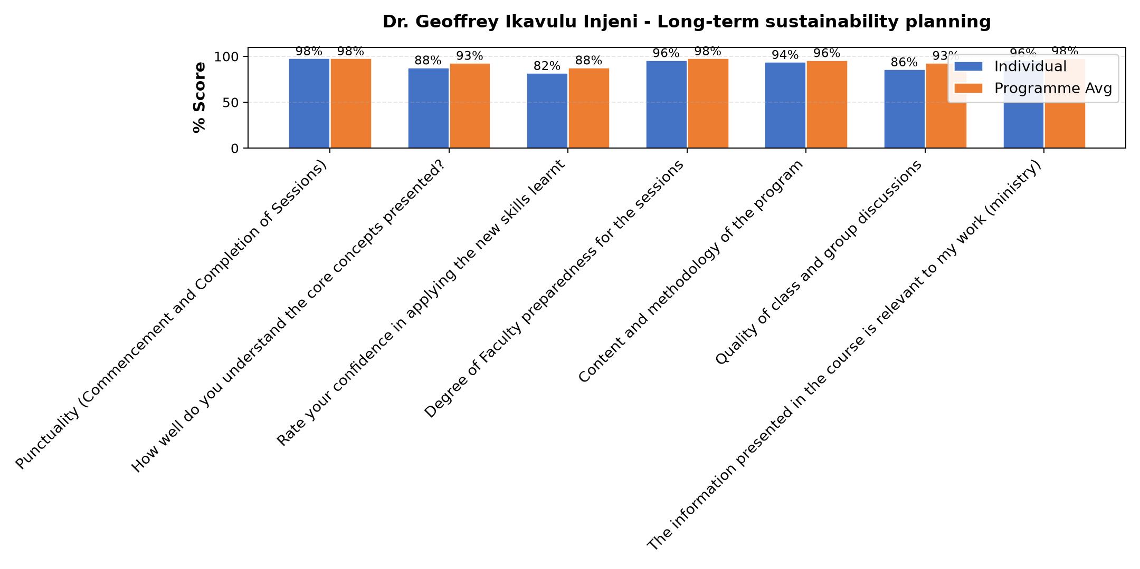

Comments & Feedback
- • Challenges in getting the finances to upgrade the project
- • Organisational changes that are affecting the project.
- • Resources and not directly involved in project
- • Lack of consideration of the 5 ps
- • If am not able to use well the information I got on how to run our enterprise
- • Government policies and financial constraints
- • The congregation structure about finances.
- • Lack of resources
SUBMITTED THROUGH:
SBS Evaluation Automation System

